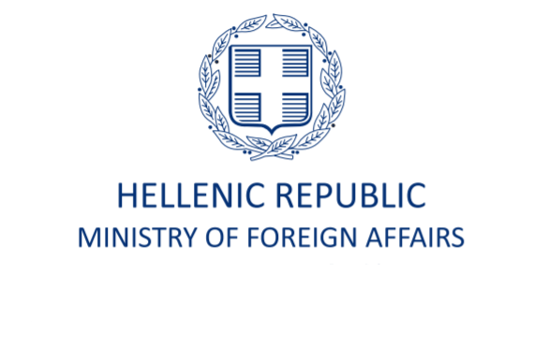
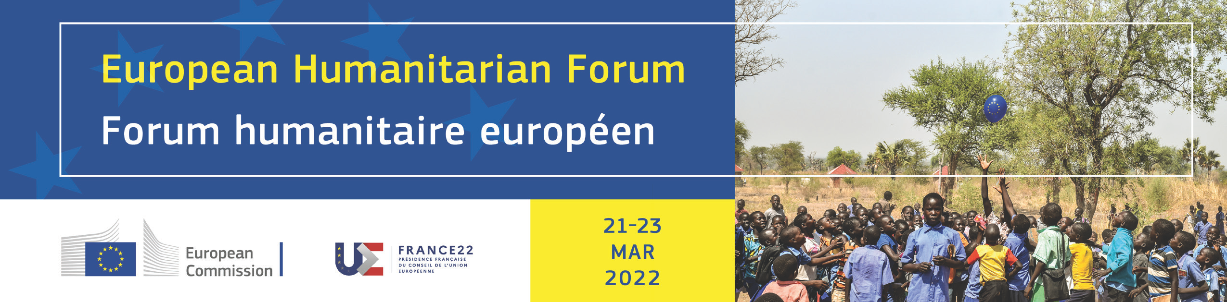

INVITATION
Humanitarian Talk: The role of the private sector in fostering local identity and culture: emergency preparedness, relief and reconstruction
under the key priority: Delivering together: expanding the resource base, addressing the root causes of crises and ultimately reducing needs
The Hellenic Ministry of Foreign Affairs in cooperation with the Heritage Management Organization invites you to follow the on-line Humanitarian Talk “Delivering humanitarian aid: The role of the private sector in fostering local identity and culture: emergency preparedness, relief and reconstruction”. The event will be held on Monday 21 March 2022, 12:00-13:00 CET. The event is organized in the context of the European Humanitarian Forum (Brussels, 21-23.03.2022).

The event aims to highlight the private sector’s potential contribution to the preservation and strengthening of local identity and cultural heritage, from emergency preparedness through to relief and reconstruction efforts in crisis zones, achieving inclusiveness, resilience and sustainability. Cultural heritage (tangible and intangible) are directly tied to local and/or national identity and subsequently to social cohesion and resilience and can become important tools during humanitarian crisis. The event aims to launch public discourse on the challenges and the perspectives of integrating culture and cultural heritage into emergency response systems and humanitarian aid policies, within the context of the humanitarian/development/peace nexus. The potential leading role of the private sector, in close collaboration with civil society organisations and public institutions, will be examined. The experience gained in various regions by the leading organizations in this field will also be shared with participants during this Talk.
Greece warmly supports efforts to expand the humanitarian assistance financial base through greater engagement with the private sector. The Talk also aims to serve as a platform for participants to exchange ideas on ways to incorporate components of cultural protection in relevant Team Europe Initiatives, guided by the principle that preparedness for humanitarian crisis is the most cost effective course of action.

The talk will be conducted in English. The virtual platform will be made available in the current week, through the following link: https://app.swapcard.com/event/european-humanitarian-forum. Livestream will also be made available on https://humanitarian.forum.europa.eu/. We encourage you to share this information with your contacts and your network.
__________________________
PROGRAMME
Welcome:
Moderator: Dr. Evangelos Kyriakidis, Director of the Heritage Management Organization

Opening address:
Mr. Nikos Dendias, Minister of Foreign Affairs of Greece

Presentations:
Protecting cultural heritage in times of war and conflict: legal framework, new challenges and current developments
Ms. Artemis Papathanassiou, Senior Legal Adviser at the Hellenic MFA

Humanitarian disaster and the experience of a new instrument
Mr. Valéry Freland, Executive Director, ALIPH Foundation, International alliance for the protection of heritage in conflict areas

Heritage in war: integration of cultural heritage protection in humanitarian actions
Mr. Isber Sabrine, Chair and co-founder of the international NGO Heritage for Peace, Leader of the Abuab Initiative, Director of the Arab Network of Civil Society Organizations to Safeguard Cultural Heritage (ANSCH),
Mr. Rene Teijgeler, co-founder of the international NGO Heritage for Peace

Discussants:
Ms. Sanne Letschert, Head of Cultural Emergency Response, Prince Claus Fund
Mr. Péter Kovács-Pifka, CEO, Hungary Helps Agency

